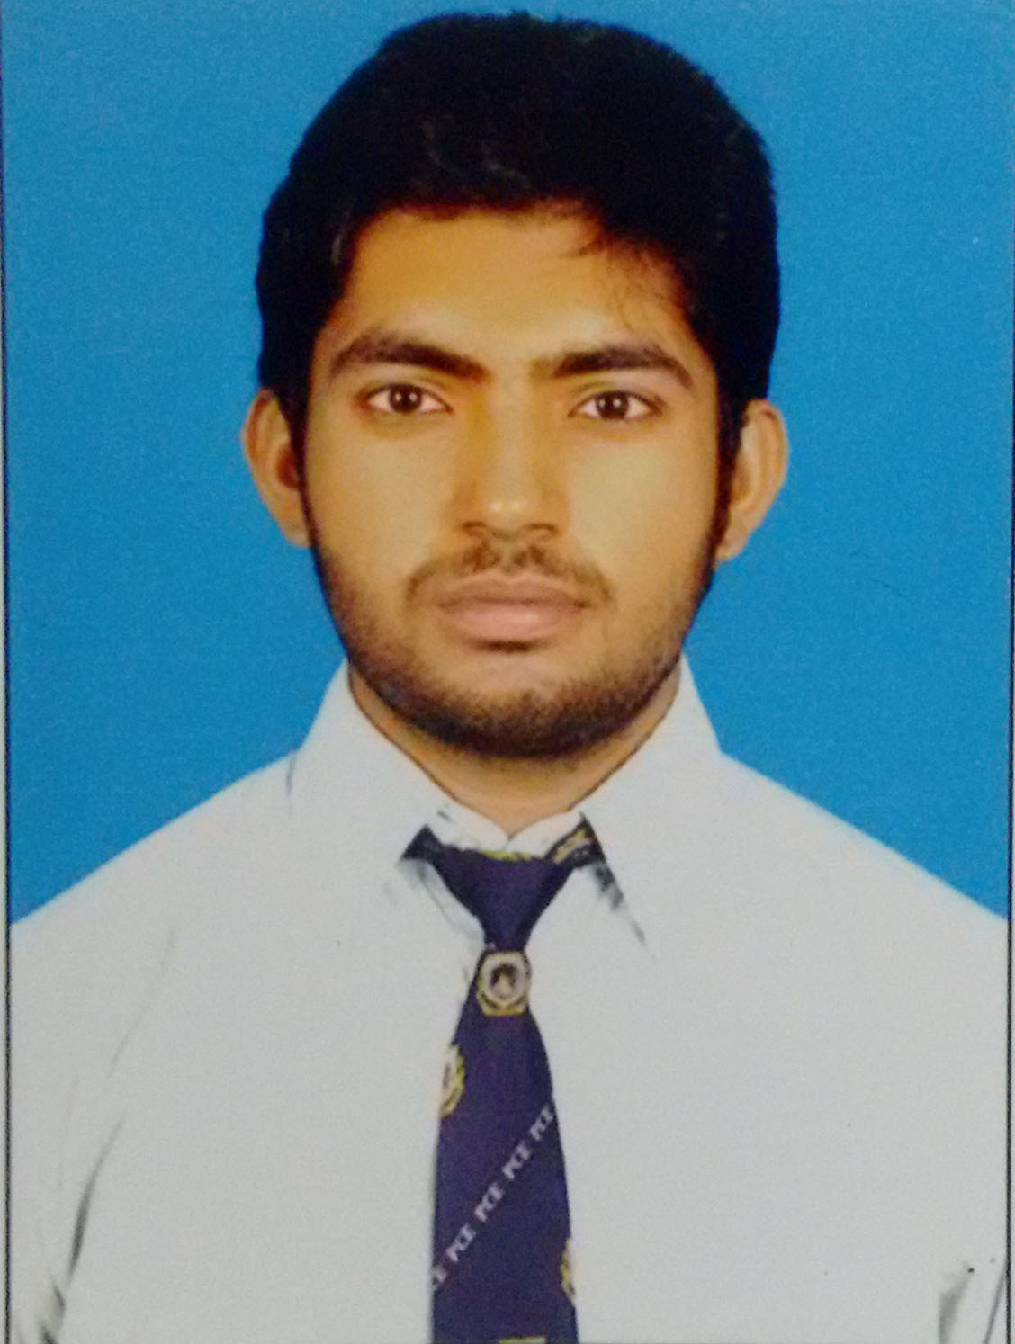
Jeetendra singh parihar
B.Tech(Electrical Engineering)
E-mail: jeetendrasingh1094@gmail.com
Contact No: +91 9680849595

PROFFESIONAL OBJECTIVES:

To work in challenging and dynamic environment and contribute towards the success of the organization as a skilful professional engineer.

EDUCATIONAL QUALIFICATION:

Standard | School/College | Board/University | Year of Passing | Aggregate (%)
B.Tech. (EE) | Poornima College Of Engineering , Jaipur | Rajasthan Technical University, Kota | 2016 | 68.27
Senior Secondary | Sanatan Dharm Shisha Sadan Dholpur | Rajasthan Board of Secondary Education | 2011 | 79.69
Secondary | Rishi Galav Vidhya Peeth, Dholpur | Rajasthan Board of Secondary Education | 2009 | 76.33
PROJECTS:
- Solar Powered Smart Irrigation System
This system consists of solar powered water pump along with an automatic water flow control using a moisture sensor.

- Versatile object counter
It is extensively use in industries for count object. It is working on principal of sensor and IR transmitter and phototransistor use as sensor.

- Three phase induction motor protection system
It is protect 3-phase induction motor from phase missing and temperature rising (over heating).it is based on relay and thermistor.

INTERNSHIP:
- Dholpur Combined Cycle Power Project, Dholpur ,Rajasthan
45 Days (16 May 2014  30 June 2015)
 Allotted with “electrical” division.
 Inspected all the sections meant for different-different processing of turbine, boiler working and Learning the conversion of mechanical energy into electrical energy efficiently

SEMINAR & Workshop:

- Participated in three day workshop on “Solar PV System by prime vision automation solutions n 30th march 2015.

TECHNICAL SKILLS
- Basics of MATLAB.
- Basics of MS Office.

ACHIEVEMENTS:
- Achieve TFWS seat in electrical engineering.
CO-CURRICULAR ACTIVITIES:

- Coordinator:
- At College social group in Poornima College of engineering, Jaipur in 2014
- To participate in culture event arrohan in Poornima College of engineering, Jaipur in 2012.

HOBBIES & INTEREST:

- Playing cricket
- Interacting with people

PERSONAL INFORMATION:

Fathers name : Mr Beerendra Parihar
Date of Birth : 10-07-1994
Nationality : Indian
Languages Known : Hindi, English
Permanent Address : shiv nagar colony,
Dholpur, Rajasthan
Pin Code-328001

DECLARATION:

I do hereby declare that the information provided herein is true to the best of my knowledge.

Date:
Place: Signature

